Inside with Hanukkah graphicsInside with Hanukkah graphics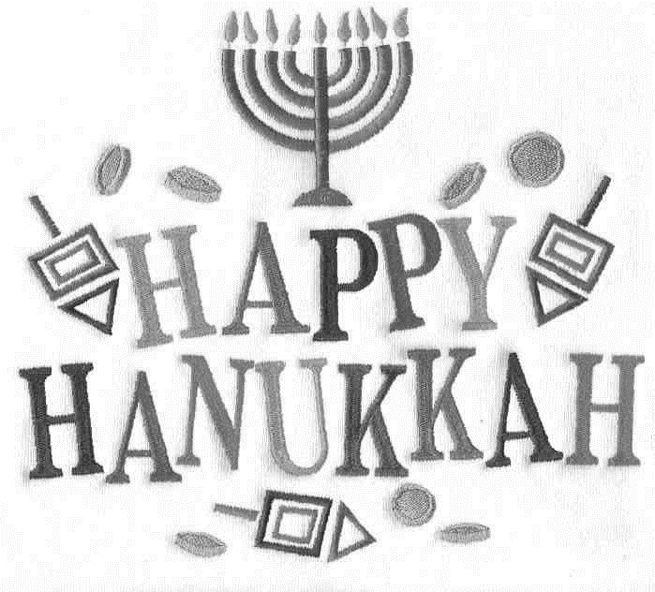

A personalized greeting card typed by

Wherever you may be,  
Whatever you may do,  
Hope the holidays  
Are bright and shining  
For you.